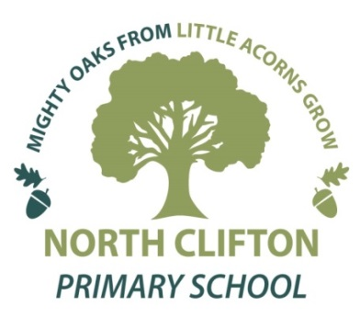**North Clifton Primary School**

Church Lane, North Clifton, Newark, Nottinghamshire NG23 7AP

Tel/Fax: 01522 778609

Head teacher: Mrs Ilona Sanderson

E-mail: [head@northclifton.notts.sch.uk](mailto:head@northclifton.notts.sch.uk)

[office@northclifton.notts.sch.uk](mailto:office@northclifton.notts.sch.uk)

[www.northcliftonschool.co.uk](http://www.northcliftonschool.co.uk)

22nd November 2024

Dear Parents and Carers,

**Trip to Newstead Abbey – Tuesday 10th December 2024**

The whole school trip (Reception to Year 6) to Newstead Abbey to experience the sights, sounds and activities of a Victorian Christmas takes place on Tuesday 10th December, and there are a number of points I would like to make you aware of:

* All children and adults have been asked to come in **Victorian style costume** – suggested details are at the end of this letter. Hopefully everyone will be able to use the same clothes worn on our Victorian Classroom Experience Day on 5th December.
* **Warmth** – we have been advised by Newstead Abbey that everyone should carry a handkerchief and dress warmly with plenty of layers of clothing. Being built of stone, the Abbey is cold within all year round.
* **Packed Lunch** – Good Lookin Cookin have amended their website so that it is possible to order a packed lunch from them for Tuesday 10th December. However, Newstead Abbey have suggested that to make the day even more authentic, packed lunches could consist of: thick sliced cheese sandwich (not grated cheese please); pickle; cooked ham; bread and jam; fruit; gingerbread biscuits; traditional lemonade or ginger beer. They have also requested no crisps or sweets.
* **Timings** – the bus needs to leave school promptly at 9am, and will not arrive back to school until just before **4pm.** We will notify you of any changes to these timings on the day itself.

We are asking for a voluntary contribution of £15.00 per child for the cost of the tickets and towards bus costs. We recognise that times are difficult, so please be reassured that no student will be excluded from the trip because of an inability to make a contribution, however, I should mention that without sufficient levels of voluntary contributions the trip will not be able to go ahead.

We would be grateful if you could return the consent slip for the trip by Wednesday 4th December at the latest.

Thank you for your support.

**Ilona Sanderson**

**Head Teacher**

**Trip to Newstead Abbey – Tuesday 10th December 2024**

I give permission for my child/ren ……………………………………………………………………….. to go to Newstead Abbey on Tuesday 10th December 2024.

I have paid a **total** of £………………..…..… by bank transfer/cash/cheque (please delete as applicable). *If paying by bank transfer please use ‘Panto’ as the reference – many thanks.*

Signed: _______________________________ Parent/Carer Date: ________________________

*Payment can be made by cash, cheque (North Clifton Primary School) or preferably by bank transfer as this reduces our costs. If paying by transfer, please put ‘Newstead’ as the reference.*

*Account Name: North Clifton Primary School*

*Bank: Barclays Bank. Sort Code: 20-63-36  Account No: 90646504*

**===============================================================**

**Victorian Costume Ideas:**

For Girls:

Long sleeve, high necked blouses or dresses

Skirts calf or ankle length, covered with a white pinafore

Tights, shawls (optional)

Hair (if long) in plaits, bunches or ringlets, pinned up

White Mop hat

For Boys:

Long sleeved shirt

Shorts to below knees (long trouser tucked into socks)

Optional: braces, neckerchief, muffler (tied like a cravat), jacket, waistcoat

Flat cap